POPULATIONS
http://www.ib.bioninja.com.au/standard-level/topic-5-ecology-and-evoluti/53-populations.html#previous-photo

5.3.1 Outline how population size is affected by natality, immigration, mortality and emigration

The change in population size over a given period of time can be summarised by the following equation: Population Size = ( N + I ) - ( M + E )

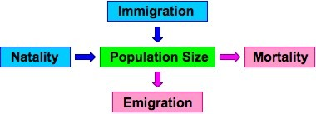
Natality: Increases to population size through reproduction (i.e. births)
Immigration: Increases to population size from external populations
Mortality: Decreases to population size as a result of death (e.g. predation, senescence)
Emigration: Decreases to population size as a result of loss to external populations

5.3.2 Draw and label a graph showing the sigmoid (S-shaped) population growth curve

Population Growth Curve
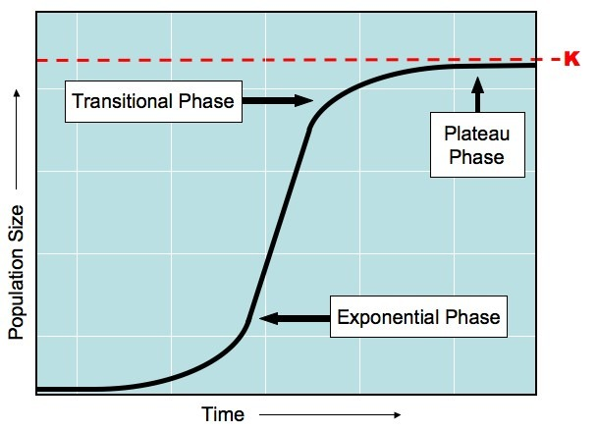

5.3.3 Explain reasons for the exponential growth phase, the plateau phase and the transitional phase

Initially, population growth may be slow, as there is a shortage of reproducing individuals which may be widely dispersed
As numbers increase and reproduction gets underway, three stages of population growth are seen:

Exponential Growth Phase
- There is a rapid increase in population size / growth as the natality rate exceeds the mortality rate
- This is because there is abundant resources (e.g. food, shelter and water) and limited environmental resistance (disease and predation uncommon)

Transitional Phase
- As the population continues to grow, eventually competition increases as availability of resources are reduced
- Natality starts to fall and mortality starts to rise, leading to a slower rate of population increase

Plateau Phase
- Eventually the increasing mortality rate equals the natality rate and population size becomes constant
- The population has reached the carrying capacity (K) of the environment
- Limited resources, predation and disease all contribute to keeping the population size balanced
- While the population size at this point may not be static, it will oscillate around the carrying capacity to remain relatively even (no net growth)

5.3.4 List three factors that sets limits to population increase

- Every species has limits to the environmental conditions it can endure and must remain within appropriate levels for population growth to occur
- Some of these factors are density-dependent, while others are unrelated to the density of the population

Factors affecting population growth:
